

Proposal for Student Undergraduate Research Award

(SURA)

2015

BACTERIAL CELL SURFACE DISPLAY OF

DIBENZOTHIOPHENE MONOOXYGENASE(DSZC)

Facilitator
Dr Preeti Srivastava, Assistant Professor
Department of Biochemical Engineering and Biotechnology
IIT Delhi

Applicants
Mira Kabra Vageesh Gupta
2013BB50022 (DBEB) 2013BB50046 (DBEB)
CGPA: 8.017 CGPA:7.672
Contact No: 8447377963 Contact No: 9899282359
email:mirakabra123@gmail.com email:vageeshguptaiitd@gmail.com

INTRODUCTION

The atmospheric environment has been deluged with exhausts from both static and moving pollution sources that burn fossil fuels and release harmful pollutants. The combustion of hydrocarbons, which contain heterocyclic sulfur compounds, and the release of sulfur into the environment in the form of particulates as well as sulfur dioxide (SO2) causes pollution in the environment. Microorganisms that have specialized in utilizing sulfur-containing compounds as substrates are being harnessed to bio-catalytically remove sulfur from fuels. This process is termed as Biodesulfurisation.But this process is not commercially feasible due to it’s low conversion rate. Through SURA we aim to increase the conversion rate and efficiency by Bacterial cell surface display of Dibenzothiophene monooxygenase(DSZC).Due to surface display of enzyme, the contact time between petroleum and enzyme decreases drastically thereby increasing conversion rate by many folds.

LITERATURE REVIEW
The conventional technique used for desulfurisation is hydrodesulfurisation(HDS).It requires extreme conditions of temperatur,pressure and it is difficult to remove stable and recalcitrant heterocyclic sulfur compounds such as dibenzothiophene (DBT) and its alkylated forms using this technique. Alternative procedures that are now been considered for desulfurization of fossil fuels include bio-catalytic desulfurization or Biodesulfurisation, where microorganisms that have specialized in utilizing sulfur-containing compounds as substrates are being harnessed to bio-catalytically remove sulfur from fuels, or at the least reduce its concentration to bearable minimum, before the final combustion of these fuels to give usable energy that drives many of our anthropogenic processes.

Biodesulfurisation has a low conversion rate which could be increased many folds by Bacterial cell surface display of enzymes. Cell-surface display allows peptides and proteins to be displayed on the surface of microbial cells by fusing them with the anchoring motifs. The protein to be displayed – the passenger protein, can be fused to an anchoring motif – the carrier protein by N-terminal fusion, C-terminal fusion or sandwich fusion. Carrier proteins have strong anchoring structure to keep fusion proteins on the cell surface without detachment. Passenger proteins is the desulfurizing agent which becomes immobilized due to its attachment with carrier protein(Carrier protein is attached to the outer membrane of the cell).

Host Strain should be compatible with the protein to be displayed and should be easy to cultivate without cell lysis. Here the host strain that we will be using is E.Coli due to the availability of various genetic tools and mutant strains and the high transformation efficiency that makes it an ideal host for screening a large peptide or protein library after surface display.
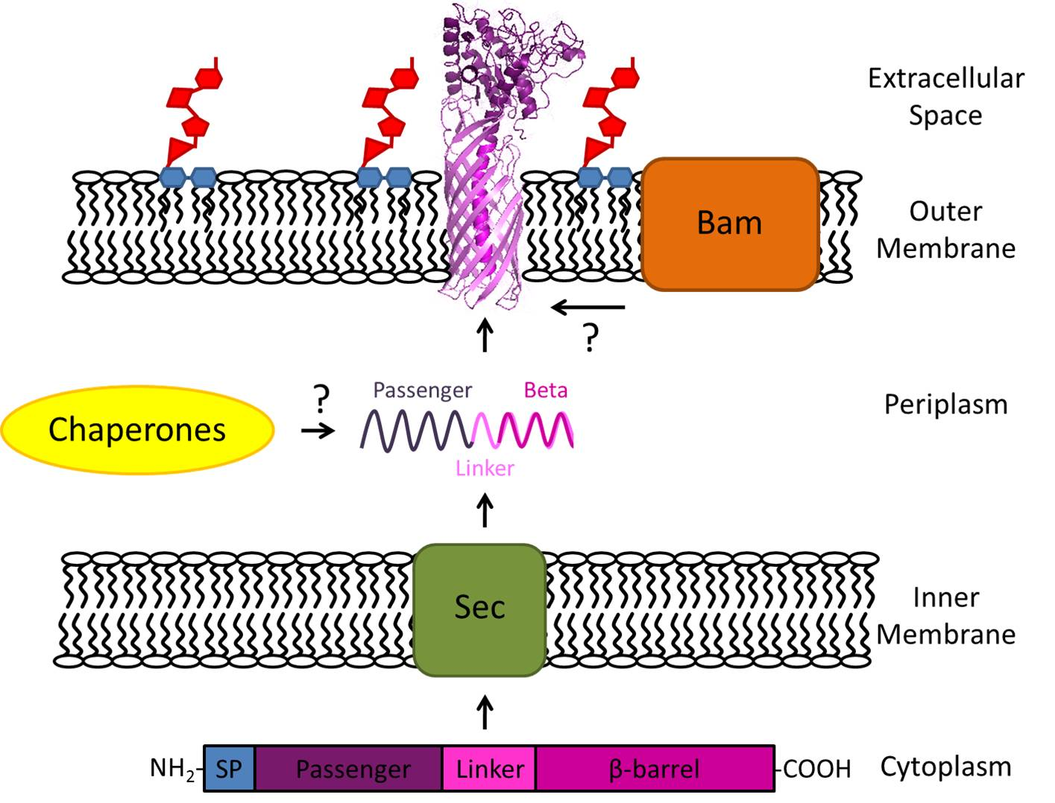

Fig. 1 Schematic diagram showing the surface display of proteins ( et al 2015. )

OBJECTIVES-
- Construction of the plasmid backbone for bacterial cell surface display
- Expression of Dibenzothiophene monooxygenase (DszC) on the surface of bacteria

METHODOLOGY-
As an overall structure for the project, we plan to do as follows:
- We will use the shuttle plasmid pRSG43(available in the lab). The gene encoding for the Bacillus anthracis exosporal protein(BclA)(Park et al 2013) will be used as the anchoring motif and will be cloned in pRSG43.
- The gene encoding for the enzyme Dibenzothiophene monooxygenase will be cloned in the vector constructed above and expression will be recorded by supplying dibenzothiophene as the substrate and NADH. The formed product Dibenzothiophene sulfon will be analysed by thin layer chromatography and finally by HPLC.

EXPECTED OUTCOME-
- Surface Display of the enzyme Dibenzothiophene monooxygenase(DSZC).
- Increase in efficiency of desulfurization power of bacteria.

TECHNICALITIES-
Duration –
Isolation of plasmid pRSG43 then digestion with restriction enzymes,preparation of competent cells,insert preparation will take around 2 weeks.Cloning of the anchoring motif and clone confirmation by restriction digestion and sequencing will take 2 weeks.Cloning of the gene encoding for dibenzothiophene monooxygenase in the constructed vector and clone confirmation will take about 1 week.The biodesulfurisation assays will take 2.5 weeks.The compilation of results and preparation of report will take around 3-4 days.

Facilities Required –
Whole of the apparatus required for this project is present in RNA-I laboratory of the Department of Biochemical Engineering and Biotechnology of IIT Delhi.

PROPOSED BUDGET-

Plasmid isolation kit = 8,000
Vent polymerase = 8,000
Restriction enzymes = 9,000
Total = 25,000/-

BENEFITS-
The prime aim of this project is to increase the conversion rate of Biodesulfurisation to make the process commercially feasible.This would help to completely overcome the problems associated with the conventional hydrodesulfurisation(HDS) process.
1.The surface display of enzyme dibenzothiophene mono-oxygenase(DszC) will efficiently convert compounds like dibenzothiophene and it’s alkylated forms to sulfone which will be amenable to hydrodesulfurization(which was not possible earlier due to steric hinderance).
2.This will be the first report demonstrating the surface display of Dibenzothiophene mono-oxygenase and its applications in biodesulfurisation.

REFERENCES-
1. Abbad-Andaloussi S, Lagnel C, Warzywoda M, Monot F (2003) Multi-criteria comparison of resting cell activities of bacterial strains selected for biodesulfurization of petroleum compounds. Enzyme Microb Technol 32: 446–454.
2. Bhatia S, Sharma DK (2010b) Biodesulfurization of dibenzothiophene, its alkylated derivatives and crude oil by a newly isolated strain Pantoea agglomerans D23W3. Biochem Eng J 50: 104–109.
3. Li, M. (2000) Applications of display technology in protein analysis. Nat. Biotechnol. 18, 1251–1256
4. Xu, Z. and Lee, S.Y. (1999) Display of polyhistidine peptides on the Escherichia coli cell surface by using outer membrane protein C as an anchoring motif. Appl. Environ. Microbiol. 65, 5142–5147
5. Bhatia S, Sharma DK (2010a) Mining of genomic databases to identify novel biodesulfurizing microorganisms. J Ind Microbiol Biotechnol 37: 425–429.
6. Dinamarca MA, Ibacache-Quiroga C, Baeza P, Galvez S, Villarroel M, Olivero P, Ojeda J (2010) Biodesulfurization of gas oil using inorganic supports biomodified with metabolically active cells immobilized by adsorption. Bioresour Technol 101: 2375–2378.
7. Guchhait S, Biswas D, Bhattacharya P, Chowdhury R (2005) Bio-desulfurization of model organo-sulfur compounds and hydrotreated diesel—Experiments and modeling. Chem Eng J 112: 145–151.
8. Strauss, A. and Gotz, F. (1996) In vivo immobilization of enzymatically active polypeptides on the cell surface of Staphylococcus carnosus. Mol. Microbiol. 21, 491 – 500

